Use Case Specification

DMT/RM01/TMP

|  |  |
| --- | --- |
| Project Code | PRJ_LeaveManagementSystem_001 |
| Project Name | LeaveManagementSystem |

|  |  |  |
| --- | --- | --- |
| Prepared/Modified by | Role | Date of Preparation |
| AAYUSHI | Analyst | 27th October00, 2017 |
| Reviewed by | Role | Date of Review |
|  |  |  |
| Approved by | Role | Date of Approval |
|  |  |  |
| Circulation List |  | Version Number of the template:1.1 |
| Version Number | 1.1 |  |

<<Customer>> REVIEW HISTORY

<<Customer comments on the Use case along with the signed off is tracked here>>

|  |  |  |  |  |  |  |
| --- | --- | --- | --- | --- | --- | --- |
| Version | 1.0 |  |  |  |  |  |
| Date | <<Date of Review>> |  |  |  |  |  |
| Reviewed by | << Reviewer Name>> |  |  |  |  |  |
| Reviewed UI Specification doc | << Whether UI Specification doc is reviewed >> |  |  |  |  |  |
| All Open Queries/issues closed | << Whether all the open queries and issues resolved>> |  |  |  |  |  |
| Agreement on Assumptions | <<Whether all the assumptions have been agreed upon by the customer>> |  |  |  |  |  |
| Sign Off | <<Signature>> |  |  |  |  |  |

Disclaimer:

The scope of the project ‘**LEAVE MANAGEMENT SYSTEM**’ is restricted to the contents of this signed off use case.

TABLE OF CONTENTS

1. Use Case Name: Login to the Leave Management System 5

2. Actor(s) 5

3. Preconditions 5

4. Flow of Events 5

4.1 Basic Flow 5

4.2 Alternative Flows 5

4.2.1 Alternate Flow 1: successful login to uas on second attempt 5

4.2.2 Alternate Flow 2 : Login to the LMS using Apply for Courses option 6

4.2.3 Alternate Flow 3 : Login to the LMS and user Apply for Leaves option and fill correct details second time 6

Exception Flow 1: Exceeded Login Attempts 6

Exception Flow 2: Web Server Down 6

Exception Flow 3: Database Connectivity Error 6

Exception Flow 4: Network Connectivity Error 7

5. Post Conditions 7

6. Special Requirements 8

Performance 8

Availability 8

User Interface 8

Security 8

7. Extension Points 8

Extension in Alternate Flow 1: 8

Extension in Alternate Flow x: 8

8. Business Rules 8

9. Diagrams 9

Use Case Diagram for 9

10. Scenarios 10

Success Scenarios 10

Failure Scenarios 10

11. Issues 10

12. UI Specifications 10

13. Inter System Dependencies 10

14. Integration with an already existing System of the <<Customer>> 10

15. Assumptions 11

1. Use Case Name: Login to the Leave Management System

**Use Case ID:**  LMS.USER.APPLYLEAVES_001

**Brief Description:** This Use Case describes the process by which employees log into the Leave

Management System and Apply Leaves

1. Actor(s)
2. Employee(User)
3. Preconditions
4. User has already registered on the Leave Management System
5. User has entered the valid URL of Leave Management System and is directed to the home page of LMS
6. User has valid user name and the password
7. Flow of Events

4.1 Basic Flow

Name: Successful login to the Leave Management System and user successfully apply leaves.

1. User clicks on the **Login** link on the Leave Management System home page.
2. The system displays **Login** page
3. User enters **Username**
4. User enters **Password**
5. User clicks on the **Login** button
6. The system validates **Username** & **Password**
7. The system navigates user to the **Apply For Leave Page**
8. User enters the start date and end date.
9. User chooses the type of Leave.
10. User enters the filter by type, absence name and reason.
11. User enters the phone no.
12. User enters the comments.
    1. Alternative Flows
       1. Alternate Flow 1:

Name: successful login to LMS on second attempt AND USER Successfully APLLY LEAVES

1. User clicks on the **Login** link on the Leave Management System home page
2. The system displays Login page
3. User enters Username
4. User enters Password
5. User clicks on the Login button
6. The system validates Username & Password
7. The system validation fails due to invalid user credentials
8. The system propmts the user to re-enter the username and password
9. The step 3 of Basic flow is followed.

* + 1. Alternate Flow 2 :

Name: Login to the LMS and user Apply for Leaves option and fill correct details second time

1. User clicks on the **Login** link on the Leave Management System home page.
2. The system displays **Login** page
3. User enters **Username**
4. User enters **Password**
5. User clicks on the **Login** button
6. The system validates **Username** & **Password**
7. The system navigates user to the **Apply For Leaves Page**
8. User forgots to enter the start date and end date.
9. User chooses the type of Leave.
10. User enters the reason.
11. User enters the phone no.
12. User forgots to enters the comments.
13. User Clicks the Submit Button
14. System Prompts the user to enter all the required fields.
15. User enters the mandatory fields.
16. User clicks on submit button.
17. System prompts the user and provides him with the leave application id.

Exception Flow 1:

Name: Exceeded Login Attempts

1. User clicks on the **Login** link on the Leave Management System home page
2. The system displays **Login** page
3. User enters **Username**
4. User enters **Password**
5. User clicks on the **Login** button
6. The system validates **Username** & **Password** for 5th time.
7. The system validation fails due to invalid user credentials and no more login attempts remaining
8. The system temporarily blocks the user account
9. The system informs the user that his/her account has been temporarily blocked.

Exception Flow 2:

name: Web Server Down

1. User clicks on the **Login** link on the Leave Management System home page
2. The system displays an error message regarding web server unavailability problem

Exception Flow 3:

Name: Database Connectivity Error

1. User clicks on the **Login** link on the Leave Management System home page.
2. The system displays **Login** page.
3. User enters **Username**
4. User enters **Password**
5. User clicks on the **Login** button
6. The system validates **Username** & **Password**
7. The system displays an error message regarding database connectivity problem.

Exception Flow 4:

Name: Network Connectivity Error

1. User clicks on the **Login** link on the Leave Management System home page.
2. The system displays **Login** page.
3. User enters **Username**
4. User enters **Password**
5. User clicks on the **Login** button
6. The system validates **Username** & **Password**
7. The system displays an error message regarding network connectivity problem.

Exception Flow 5:

Name: user leaves the apply leave form blank and click on submit

1. User clicks on the **Login** link on the Leave Management System home page.
2. The system displays **Login** page.
3. User enters **Username**
4. User enters **Password**
5. User clicks on the **Login** button
6. The system validates **Username** & **Password**
7. Apply for Leaves page is displayed.
8. User keeps the form blank and click on submit button.
9. System prompts the user to enter the Required details.
10. Post Conditions

| Flow Name | Post Condition |
| --- | --- |
| successful login to LMS on second attempt AND USER Successfully APPLY LEAVES | User will be logged in to the LMS successfully and system should navigate user to the Apply For Leaves Page and user apply for leaves successfully. |
| successful login to LMS on second attempt AND USER Successfully APLLY LEAVES | User will be logged in to the LMS successfully and system should navigate user to the Apply For Leaves Page and user apply for leaves successfully. |
| Exceeded Login Attempts | The system should suspend the user account and should inform the user that his/her account has been blocked. |
| Web Server Down | The system should display an error message to the user regarding web server unavailability problem. |
| Database Connectivity Error | The system should display an error message to the user regarding the database connectivity problem. |
| Network Connectivity Error | The system should display an error message to the user regarding the network connectivity problem. |
| User leaves the apply leave form blank and click on submit | The System Prompts the user to enter all the required fields. |

1. Special Requirements

Performance

1. The click on Ok button of login shall display the Apply For Leave page within 5 seconds of user request

Availability

* 1. The Employees can Apply for leaves only on working days 24x7 but cannot register on national holidays.

User Interface

* 1. The Labels of the form shall be bold
  2. All the by drop down menus should have a default option
  3. Mandatory fiels should be marked by astricks
  4. The logout and back button should be available on every page of the application

Security

1. Remember my credential option should save username and password in html cookies.
2. The LMS will allow user to Cancel the applied leave at any point.
3. Extension Points

Extension in Alternate Flow 1:

In step 7, if the customer has entered wrong user credentials :

1. The system prompts the user to re-enter the credentials

2. User enters the username and password

3. The system takes user to the **Step 3** of **Basic Flow**

1. Business Rules

| Business Rule Name | Business Rule Description | System action (if BR fails) |
| --- | --- | --- |
| BR01 | User must be valid | User is prompted to re-enter the login credentials |
| BR02 | User can view his application status only by entering valid Application_Id | Displays error message “Invalid Application_Id” |

1. Diagrams

Use Case Diagram for

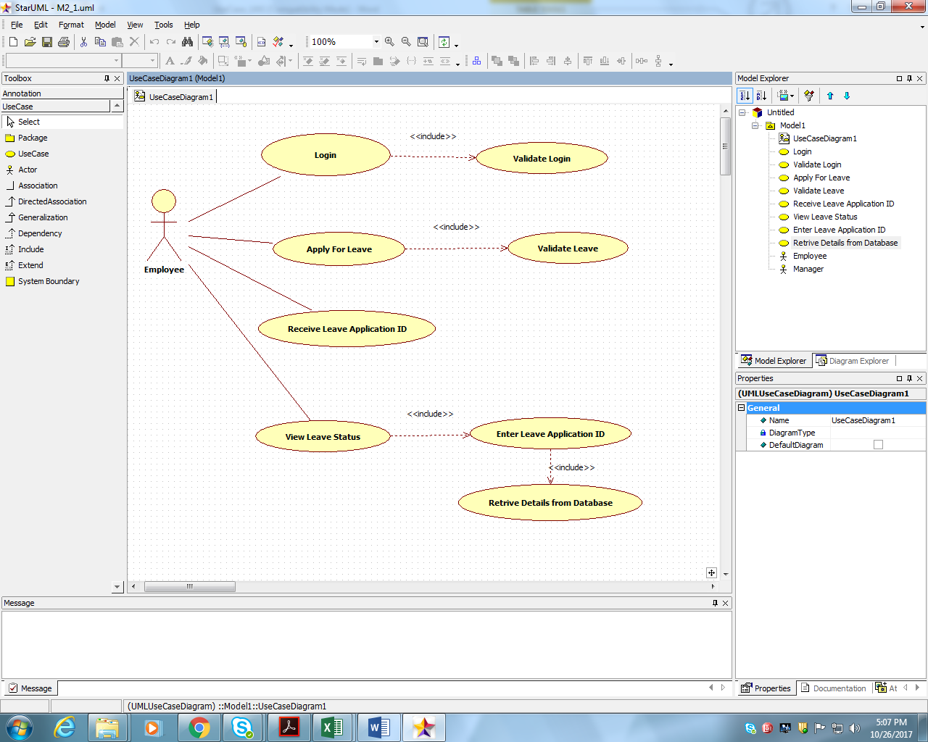

1. Scenarios

Success Scenarios

* Successful login to LMS on second attempt AND USER Successfully APPLY
* Successful login to LMS on second attempt AND USER Successfully APLLY LEAVES

Failure Scenarios

* Exceeded Login Attempts
* Web Server Down
* Database Connectivity Error
* Network Connectivity Error
* User leaves the apply leave form blank and click on submit

1. Issues

* What is the maximum size of username and password that a user can have ?
* What if the user is blocked after invalid login attempts for three times ?

1. UI Specifications

<< Provide a link to the UI specification document of the Use case. Please don’t embed the document here>>

1. Inter System Dependencies

**Module: ‘**Apply Online for Leaves’ gets impacted due to :

Use case name: Alternate Flow 1

**Impact**: If the user tries to apply for leaves without login, he should be denied to do so.

1. Integration with an already existing System of the <<Customer>>

<< This is especially applicable if the project at hand is an enhancement to an existing system.>>

1. Assumptions

<< List down all the assumptions considered by this use case>>

REVISION HISTORY OF THE WORK PRODUCT

<to be maintained by projects>

|  |  |  |  |  |  |
| --- | --- | --- | --- | --- | --- |
| # | Date | Version # | Section Changed | Details of changes made | Approved By |
| 1 |  |  |  |  |  |
| 2 |  |  |  |  |  |